|  |
| --- |
| Benutzerhandbuch WorldViz & CAVE  Konfiguration  **Daniel Inversini**  **Julien Villiger**  **V1.00, 06.11.2015** |
| **Berner Fachhochschule**  Technik und Informatik  Informatik |

Inhalt

[Konfiguration 1](#_Toc437602792)

[1 Einleitung 3](#_Toc437602793)

[1.1 Kurzfassung 3](#_Toc437602794)

[2 Systemvoraussetzungen 4](#_Toc437602795)

[3 Benutzung 4](#_Toc437602796)

[3.1 Starten der Kameras 4](#_Toc437602797)

[3.2 Starten des WorldViz Studios 5](#_Toc437602798)

[3.2.1 Verwenden des WorldViz über eine gespeicherte Konfiguration 6](#_Toc437602799)

[3.2.2 Verwenden des WorldViz mit einer Neukonfiguration 6](#_Toc437602800)

[3.3 Sequenzielles Einschalten der Komponenten 8](#_Toc437602801)

[4 FAQ 8](#_Toc437602802)

[5 Weitere Hinweise 9](#_Toc437602803)

[5.1 Reseten des Wand 9](#_Toc437602804)

[5.2 Rekalibrierung des CAVE 9](#_Toc437602805)

[6 Anhang WorldViz Hilfe 9](#_Toc437602806)

[6.1 Configuring WorldViz PPT system for wand use 10](#_Toc437602807)

[6.1.1 Enabling the wand using a single light with Marker ID 10](#_Toc437602808)

[6.1.2 Reset/Calibrate wand’s virtual North 12](#_Toc437602809)

[6.2 PPT Eyes Setup 13](#_Toc437602810)

[6.2.1 Starting the Plugin 13](#_Toc437602811)

[6.2.2 Configuring PPT Eyes 14](#_Toc437602812)

[6.3 PPT Wand with PPT Eyes 16](#_Toc437602813)

[6.3.1 Configure PPT Eyes 16](#_Toc437602814)

[6.4 Calibrating 19](#_Toc437602815)

[6.4.1 Standard calibration 19](#_Toc437602816)

[6.4.2 Chained calibration 20](#_Toc437602817)

[6.4.3 Clearing calibrations 21](#_Toc437602818)

[7 Abbildungsverzeichnis 21](#_Toc437602819)

[8 Versionskontrolle 22](#_Toc437602820)

# Einleitung

Dieses Dokument dient dazu, die Software „PPT Studio 2013“ zu konfigurieren. Dazu gehört insbesondere:

* Das Booten der Komponenten
* Die Überprüfung der Kameras
* Die Überprüfung und Konfiguration der Plugins
* Das sequenzielle Einschalten der Geräte und deren Verwendung

sowie erweiterte Themen, namentlich:

* Das Kalibrieren des CAVEs
* Das Resetten des Wand-Devices

Weitere Schritte sollten Mithilfe der WorldViz Hilfe durchgeführt werden, dies ist nicht Teil dieser Dokumentation.

## Kurzfassung

1. Starten des PPT Servers
2. Starten des DHCPs für die Kameras
3. Starten der Kameras
4. PPT Studio öffnen
5. Aktuelle Config laden
6. Wand mit einem LED starten
7. Wand verbinden über das Post Process Plugin
8. Wand resetten in der Resetbox am Boden des CAVEs
9. Eyes verbinden

# Systemvoraussetzungen

Überprüfen und starten Sie folgende Systeme:

* TS1, Trackingserver im Rack
* CS0, Benötigt für den Videomatrix Switch

Loggen Sie sich ein auf dem TS1 mit einem gültigen Account. (Benutzername cpvr oder Adminaccount).

# Benutzung

## Starten der Kameras

Verwenden Sie folgende Verknüpfungen:

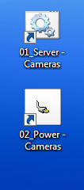

Abbildung 1: Verknüpfungen Desktop

* 01\_Server – Cameras

Startet einen DHPC-Server welcher IP’s für die Kameras verteilt. Dies ist dann Sichtbar in der Ausgabe des Servers (Abbildung 3).

* 02\_Power – Cameras

Öffnet einen Hyperlink zu einer gemanagten Steckerleiste. Dort können die Kameras auf „on“ geschalten werden.

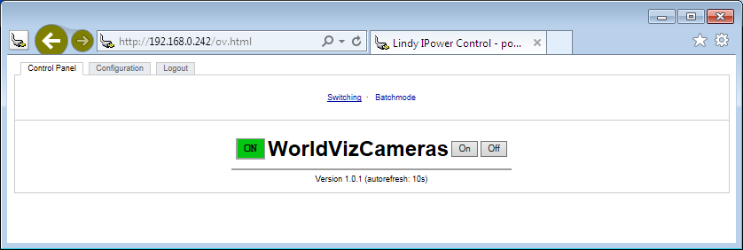

Abbildung 2: Ein-, Ausschalten der Kameras

Der DHCP-Server für die Infrarotkameras hat eine Kommandozeilenausgabe, welche bei erfolgreichem Starten wie folgt aussieht:

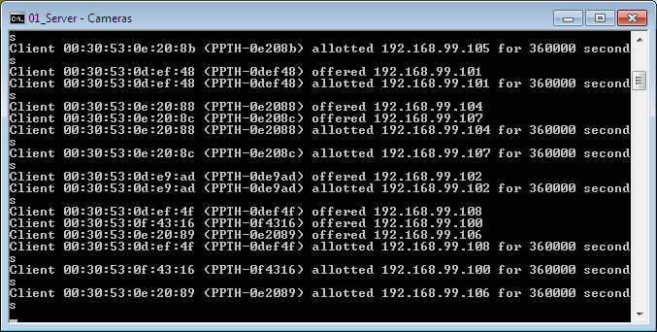

Abbildung 3: Ausgabe DHPC-Server Kameras

## Starten des WorldViz Studios

Verwenden Sie folgende Verknüpfungen:



Abbildung 4: Verknüpfungen WorldViz

***Falls eine Warnung des Windows UAC (User Account Control) kommt, bitte bestätigen Sie mit OK.***

### Verwenden des WorldViz über eine gespeicherte Konfiguration

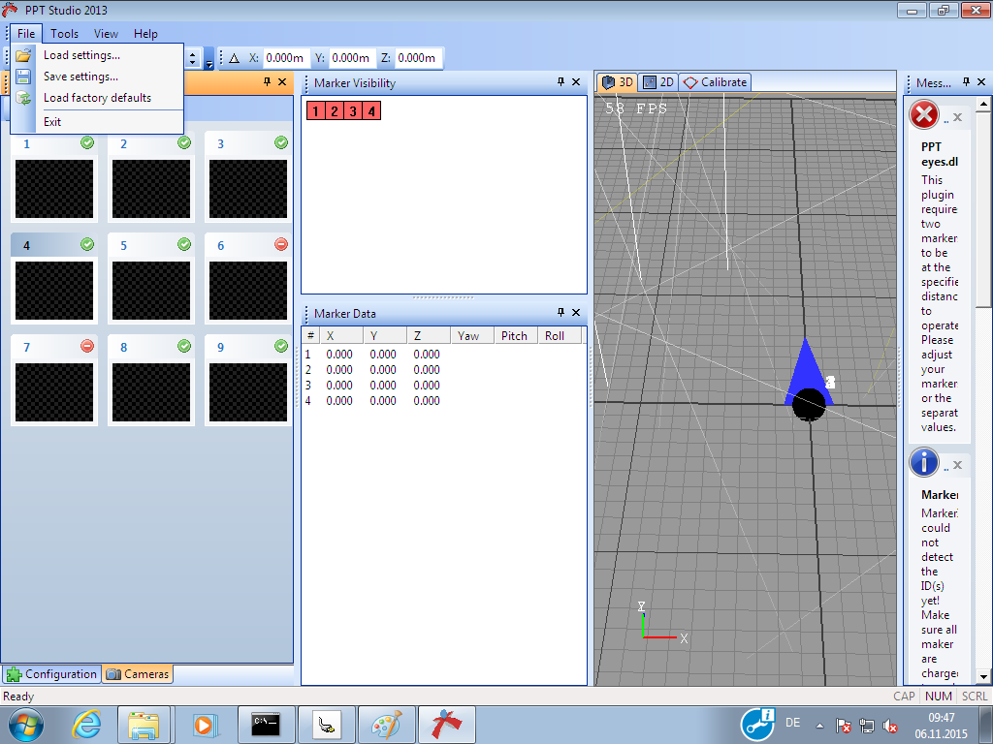

Abbildung 5: Konfiguration laden

Wählen sie im Dialogfenster dann die gewünschte Konfiguration. Damit können Sie bereits das WorldViz Studio verwenden.

Wir empfehlen jeweils die neuste stable-Version der vorhandenen Konfigurationen zu verwenden. Diese sind Identifizierbar mit Prefix «PPT».

### Verwenden des WorldViz mit einer Neukonfiguration

***Achtung, folgender Abschnitt empfiehlt sich nur für erfahrene Benutzer.***

Falls Sie das WorldViz Studio neu konfigurieren möchten, benötigen Sie folgende Plugins:

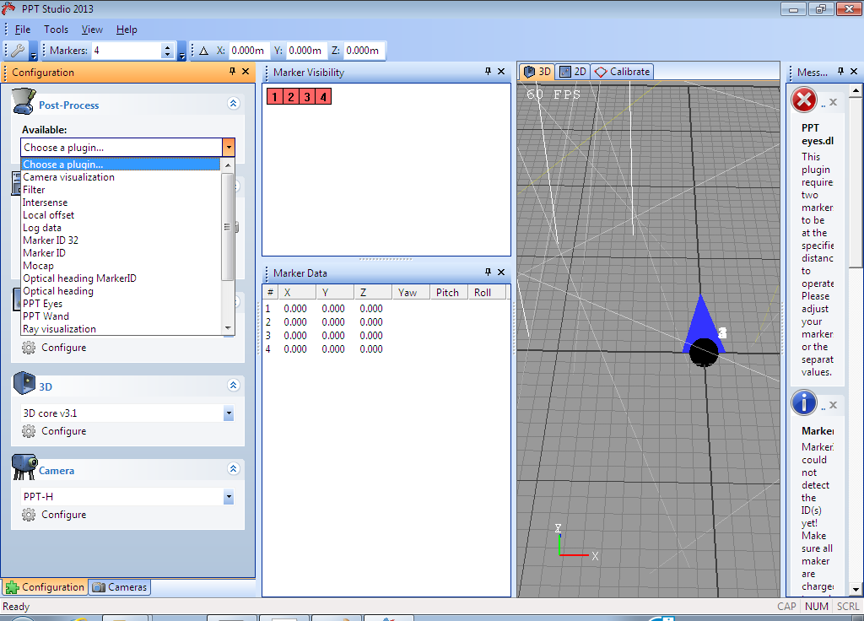

Abbildung 6: WorldViz Post-Process Plugins

* Marker ID
* PPT Wand
* PPT Eyes

Sowie für den Output:

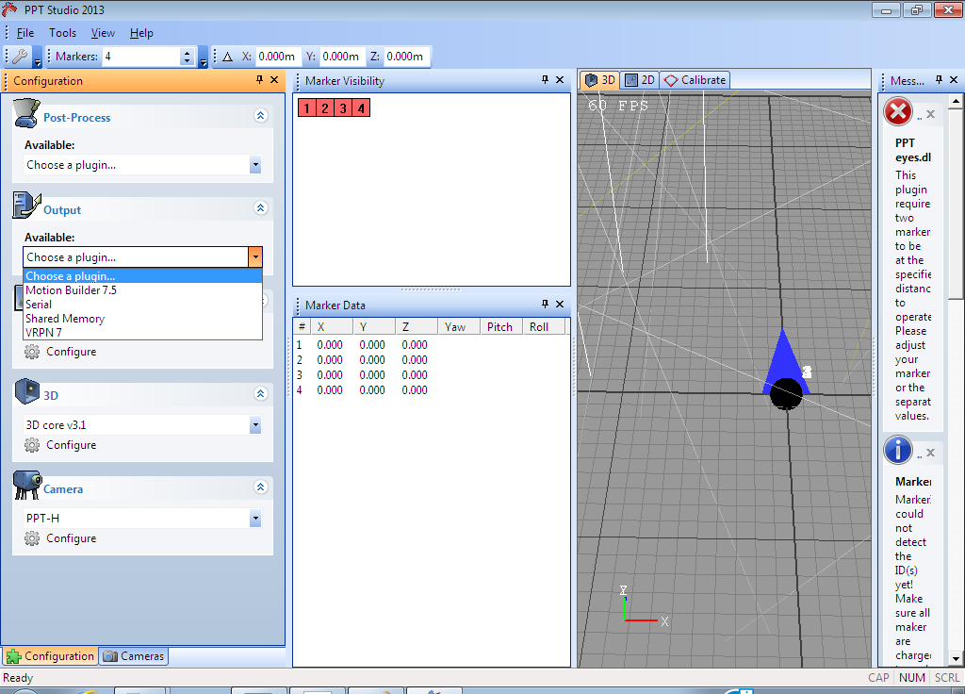

Abbildung 7: WorldViz Output-Plugins

* VRPN 7

Führen Sie die Konfiguration der Plugins anhand der WorldViz Hilfe durch. (Siehe Anhang WorldViz Hilfe).

## Sequenzielles Einschalten der Komponenten

Komponenten in dieser Reihenfolge einschalten:

1. PPT Wand mit einem Marker einschalten (Schalter nach unten)
2. PPT Wand verbinden

Verbinden Sie diesen über das Popupmenu auf dem PPT Wand Plugin.

1. PPT Eyes einschalten
2. PPT Wand kalibrieren

Verwenden Sie dazu die Kalibrierungsbox und platzieren Sie diese in der Mitte des CAVEs am Boden, Ausrichtung nach vorne.

# FAQ

Q: Wie muss ich mich auf dem TS1 einloggen?

A: Wenden Sie sich an einen Verantwortlichen des CPVR-Labs.

Q: Die Kameras verbinden sich nicht mit dem DHCP-Server

A: Führen Sie ein „ipconfig –flushdns“ durch oder rufen Sie [www.google.com](http://www.google.com) auf.

Q: Der Wand funktioniert nicht korrekt.

A: Vergewissern Sie sich, dass Sie den Wand auf 1 LED eingestellt haben.

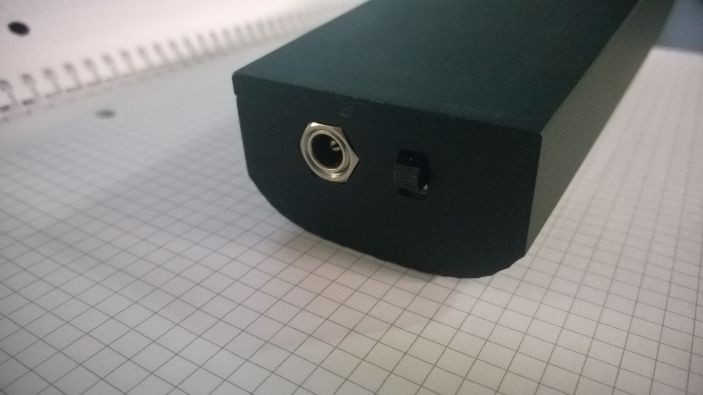

Abbildung 8: PPT Wand 1, 2 LED's

Q: Die Eyes funktionieren nicht :

A: Vergewissern Sie sich, das diese eingeschalten sind.

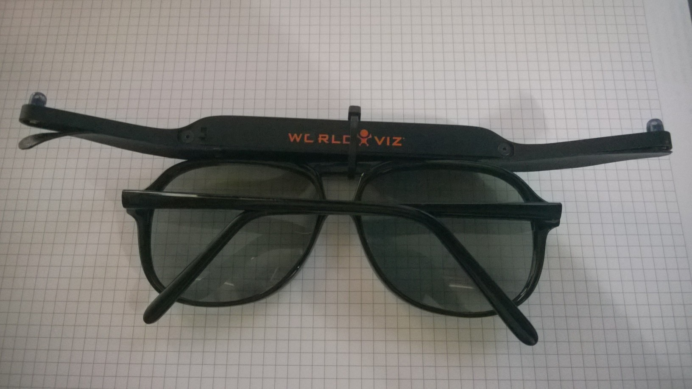

Abbildung 9: PPT Eyes

# Weitere Hinweise

## Reseten des Wand

Öffnen Sie das Wand-Plugin im PPT-Studio und reseten Sie den Wand über das Kontextmenu:

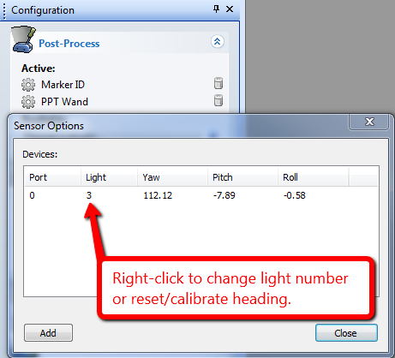

Abbildung 10: WorldViz Reset Wand

## Rekalibrierung des CAVE

Sehen Sie dazu Kapitel 6.4.

# Anhang WorldViz Hilfe

***Folgende Anhänge sind Copyright bei Worldviz. Sie wurden aus der Hilfedatei extrahiert um eine möglichst vollständige Dokumentation für den CAVE der BFH bereitzustellen.***

## Configuring WorldViz PPT system for wand use

### Enabling the wand using a single light with Marker ID

1. Turn the wand on (1 light mode is switch down position) before starting PPT Studio (because PPT Studio automatically attempts to connect to the wand if it was last used with a wand connected)
2. Place the wand on a stable, non-metallic surface with joystick pointing up
3. In the Configuration pane, add “Marker ID” under Post-Process options if it’s not already added using the dropdown menu. This plug-in must be topmost in your list of plug-ins (drag to reorder if necessary). If you have a factory configured wand, its Marker ID is 3 for single light use (right hand).
4. Click on Post- Process / Marker ID and uncheck “Automatically search inventory” if it is currently selected. Instead, put a checkmark for ID 3 under the list of physical IDs and do not change the virtual ID value. NOTE: If you’re also tracking other markers in your scene, ie. PPT Eyes, you must now use the Marker ID plug-in to establish the number and ID of the other markers. See your PPT manual for details about Marker ID. Hit “OK” when you complete the selections.

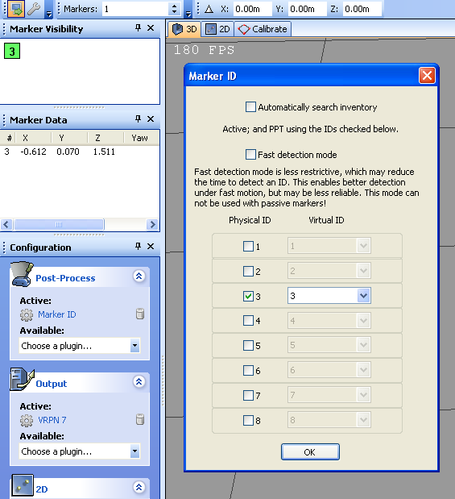

Abbildung 11: WorldViz: Wand 1

1. In the Configuration pane, add “PPT Wand” under Post-Process options if it’s not already added using the dropdown menu. It might take few seconds to load. This plug-in must be beneath Marker ID in your list of plug-ins.

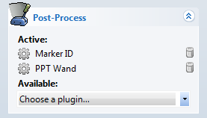

Abbildung 12: WorldViz Wand 2

1. Click on Post-Process / PPT Wand, and add an orientation sensor if none is presently added. To add a sensor, press the “Add” button and enter 0 (zero) for port number and hit “Add”; this will auto-detect the wand.
2. Configure the light number (in Post-Process / PPT Wand) by right-clicking the row showing the wand data. Under normal circumstances, this will be 3 (the marker ID of your wand). Hit “OK”.
3. The current screen should be similar to the one shown below and finally hit “Close” to complete the PPT Wand configuration.

**NOTE:** For magnetic compensation (2 light) mode of the PPT Wand, please refer to section “[Compensation for magnetic distortion](file:///C:\Users\Daniel\AppData\Local\Temp\CHM%20Editor\ppt_42314.4058039352\Compensation%20for%20Magnetic%20Distortion.htm)” for further details.



Abbildung 13: WorldViz Wand 3

### Reset/Calibrate wand’s virtual North

1. Since the wand uses a magnetic sensor in the standard 1 light mode, you need to reset the straight ahead or North direction.
2. Click on Post-Process / PPT Wand
3. Right-click on the row showing the Wand data and select “Reset”
4. Follow the Reset Wizard to completely calibrate your wand (Normally, you want to have your wand’s LED end pointing to the Z direction or to the screen)
5. Hit “Close.” Your calibration is now complete and is stored; the next time you run PPT you do not need to reset the wand

## PPT Eyes Setup

The PPT Eyes is part of the Worldviz PPT product family and integrates into any PPT system. This page describes the setup of PPT Eyes.

### Starting the Plugin

1. Start PPT Studio.
2. Setup PPT and calibrate the tracking system according to the instructions given in the PPT Studio Help.
3. Set the number of tracked markers to at least 2 and turn on the PPT Eyes device. You should now see two tracked lights in the 3D view. You will need to increase this value to be larger than 2 if you are tracking other objects in your environment.  
     
   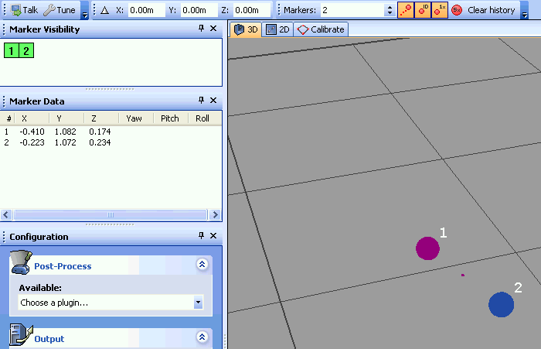

Abbildung 14: WorldViz Eyes 1

1. Next, enable the PPT Eyes plugin by choosing it from the Post-Process list. PPT Eyes will now automatically detect the two tracked lights and merge them into a single traced light with orientation data. Check the Marker Visibility panel that this is so. The 3D view should also show a single tracked light with an axis to indicate orientation data.  
     
   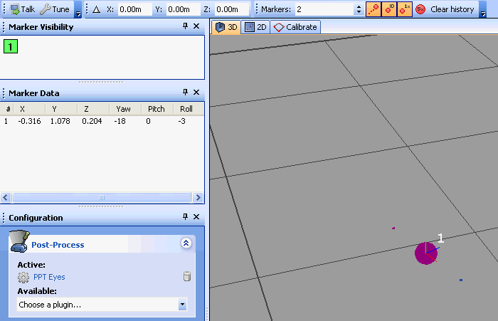

Abbildung 15: WorldViz Eyes 2

1. PPT Eyes will flip the orientation by 180 degrees if the plugin determines that the user is facing away from the display. Because of this you may see an error warning in the Messages panel. This is normal operation. If you find that the orientation is incorrect, face towards PPT north and the orientation will correct itself.  
     
   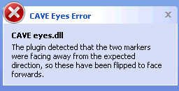

Abbildung 16: WorldViz Eyes 3

### Configuring PPT Eyes

To configure PPT Eyes, click on the PPT Eyes plugin in the active list. This will bring up the Settings dialog.

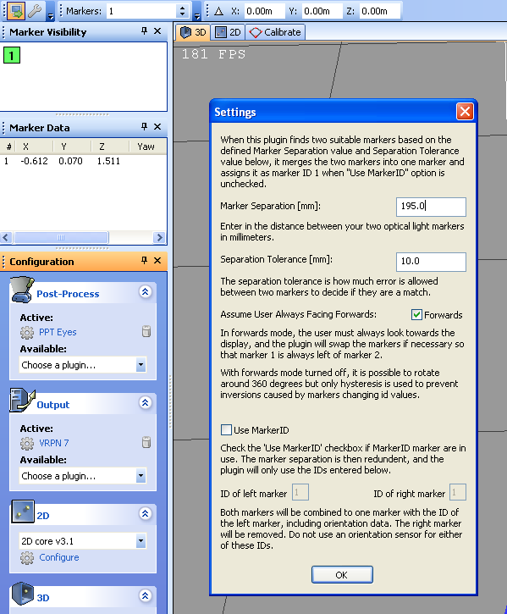

Abbildung 17: WorldViz Eyes 4

**Marker Seperation:** This is the distance between the two LED lights on the PPT Eyes device. By default this should by 195 mm. *Do not change this unless instructed to by Worldviz support, or if you have built your own custom LED device.*

**Separation Tolerance:** This is the maximum absolute difference between the observed distance of the two LED lights on the PPT Eyes device and the Marker Separation value can be. PPT Eyes will fail to detect the device if this tolerance is exceeded.

**Assume User Always Facing Forwards:** By default this mode should be turned off. The standard operating mode allows the user to rotate around and attempts to guess which direction PPT north is located. If you enable always facing forwards mode, it will be impossible to look more than 90 degrees from PPT north, and no previous information will be used to auto-detect the direction.

**Use MarkerID:** If you are using MarkerID-based markers, then you can skip the need to detect markers based on separation, and can use the IDs directly. This mode is only useful if you have built your own custom LED device, and should not be used with the standard PPT Eyes device.

## PPT Wand with PPT Eyes

PPT Eyes is a device that provides position and orientation tracking of a user’s head and is typically mounted onto a pair of 3D glasses for viewing a 3D projection screen. PPT Eyes is designed to work in conjunction with PPT Wand, and together they provide a rich head and hand interactive solution for CAVE and powerwall environments.

Using PPT Eyes in conjunction with PPT Wand is as simple as combining the configuration for the two stand-alone devices. Below the configuration technique for PPT Eyes is provided. If the Marker ID and PPT Wand plug-ins have not been set up, it is recommended to follow section 2.2 “Configuring WorldViz PPT system for wand use” at this stage. While PPT Eyes do not need to be configured first, its plug-in should always be moved to below the “Marker ID” and above the “PPT Wand” in the Post-Process stack (drag to reorder).

### Configure PPT Eyes

1. Turn on PPT Eyes (slide the micro-switch on the back to the top)
2. Place PPT Eyes in the tracking field where both LED markers can be seen.
3. Correctly set PPT Studio number of markers (the Eyes count as 2 additional markers so adjust accordingly)
4. With standard PPT Eyes and Wand configuration, you would have 3 markers in total. Remember to select additional 2 marker IDs in the Marker ID plug-in. Normally, we uncheck the “automatically search inventory” and manually select physical ID 1, 2, and 3 for the PPT eyes and wand. Add “Marker ID” under Post-Process options if it’s not already added. NOTE: It is not necessary to add Marker ID plug-in if you use PPT Eyes alone.
5. In the Configuration pane, add “PPT Eyes” under Post-Process options if it’s not already added using the dropdown menu.

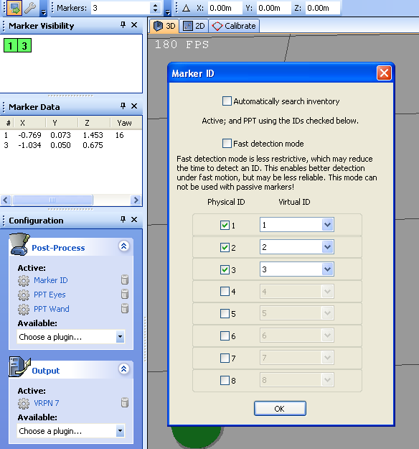

Abbildung 18: WorldViz Wand & Eyes 1

1. Drag to re-order PPT Eyes so that it is below “Mark ID” and above “PPT Wand” in the Post-Process.

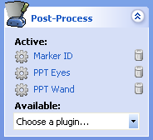

Abbildung 19: WorldViz Wand & Eyes 2

1. You should not need to configure the PPT Eyes plug-in as its default settings are correct for nearly all uses. The default value is shown below.
2. You should now see orientation data shown for marker ID # 1. This is the ID data computed from the PPT Eyes’ two LED markers.

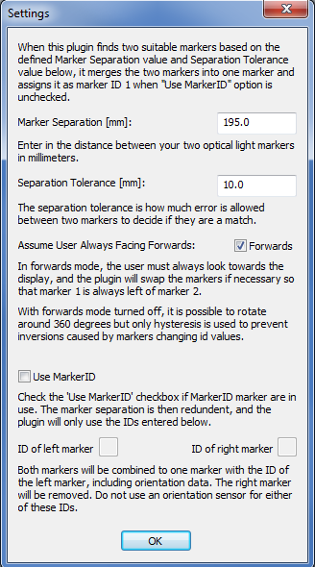

Abbildung 20: WorldViz Wand & Eyes 3

## Calibrating

**NOTE for PPT-X users**:

Before running the calibration wizard, you need to be absolutely certain that your cameras are connected in the correct order. To verify this, wave your hand or a marker in front of each camera and double-check that each camera's physically labeled number matches it's number in the PPT software interface. A mismatch cannot be detected by the software and calibration will be possible but the calibration quality will be significantly deteriorated. PPT-E and PPT-H systems automatically identify themselves and ensure correct connections.



Abbildung 21: WorldViz Kalibrierungsrig

### Standard calibration

In this method, all cameras are calibrated simultaneously.

1. Before continuing, ensure that you have configured your PPT cameras to optimal sensitivity and thresholds, and that your workspace lighting is ready for data collection (e.g., outside windows blocked, warm lights off).
2. Turn off all of your PPT markers.
3. Turn on the PPT calibration rig and place it in the center of your workspace. Orient the calibration rig so that the +X and +Z axis markers are aligned in the directions that you desire for PPT's coordinate system. PPT north is defined as the direction of the +Z axis.
4. Try to keep the rig as close to the center of each camera's field-of-view as possible.  Avoid placing the calibration rig markers at extreme edges of a camera's view. Use the Cameras panel to view all of the cameras simultaneously.
5. Click the Calibrate tab in the main viewport. This will launch the calibration wizard.  
     
   C:\Users\Daniel\AppData\Local\Temp\CHM Editor\ppt_42314.4058039352\image112.gif

Abbildung 22: WorldViz Kalibrierungstab PPT Studio

1. Find the Calibration Rig Size options and select the proper calibration rig size. The size is defined by the distance between the adjacent IR LEDs. In general, a system usually comes with a calibration rig which has the default size (57cm).   
     
   C:\Users\Daniel\AppData\Local\Temp\CHM Editor\ppt_42314.4058039352\images\rig_size_options.png

Abbildung 23: WorldViz PPT Studio Kalibrierungseinstellungen

1. For a standard calibration, all cameras should be reset to Uncalibrated (as indicated by the red icon next to each camera). If this is not the case, click the Reset button before proceeding.  
     
   C:\Users\Daniel\AppData\Local\Temp\CHM Editor\ppt_42314.4058039352\image111.gif

Abbildung 24: WorldViz PPT Studio Kalibrierungseinstellungen Camera 1

1. Click the Calibrate button at the top of the window. Each of the camera's four indicator lights will turn green for each flash of the PPT calibration rig. If any camera fails to light up all green, then there was a problem with that camera seeing all four markers of the PPT calibration rig. Use the Cameras panel to re-examine that camera.
2. If all cameras calibrated successfully, you'll receive a quality score. Good scores are in the range of 95-100; scores greater than 90 are still acceptable.  
     
   C:\Users\Daniel\AppData\Local\Temp\CHM Editor\ppt_42314.4058039352\image113.gif

Abbildung 25: WorldViz PPT Studio Kalibrierungseinstellungen Camera 2

### Chained calibration

In this method, cameras are calibrated in stages. Use this method for a physical workspace where not all cameras can see the calibration rig simultaneously (e.g., the room is L-shaped).

1. Follow steps 1 - 4 above.
2. If you're starting a new chained calibration, click the Reset button to clear all previous data.
3. Click the Calibrate button at the top of the window. Each of the camera's four indicator lights will turn green for each flash of the PPT calibration rig.
4. Cameras that are fully calibrated are now indicated with the green checkmark icon. Cameras that show a yellow icon indicate that the camera saw all four makers on the calibration rig but it cannot yet chain due to lack of data from a neighboring (connecting) camera. Cameras that show a red icon indicate cameras that saw less than four markers on the calibration rig.
5. Move the calibration rig enough so that some or all those cameras indicated as red can now fully see the calibration rig.
6. Once all cameras are calibrated, you'll receive a quality score. Good scores are in the range of 95-100; scores greater than 90 are still acceptable.

**NOTE about chaining**

Use as few calibration snapshots as possible, typically this is done by "sweeping" the calibration rig from one end of the space to the other. If you suspect a camera calibrated but may contain poor measurements (e.g., the rig was at the extreme edge of the camera's view), you can easily right click on the camera to mark it as uncalibrated, and then redo it.

### Clearing calibrations

From either the Cameras panel or the 2D view, you can right-click a camera and select Clear calibration to void a particular camera's calibration, forcing the PPT system to re-calibrate it during the next calibration. You can also clear all or some cameras directly in the Calibration guide.

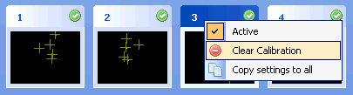

Abbildung 26: WorldViz PPT Studio Kalibrierung löschen

# Abbildungsverzeichnis

Abbildung 1: Verknüpfungen Desktop 4

Abbildung 2: Ein-, Ausschalten der Kameras 4

Abbildung 3: Ausgabe DHPC-Server Kameras 5

Abbildung 4: Verknüpfungen WorldViz 5

Abbildung 5: Konfiguration laden 6

Abbildung 6: WorldViz Post-Process Plugins 6

Abbildung 7: WorldViz Output-Plugins 7

Abbildung 8: PPT Wand 1, 2 LED's 8

Abbildung 9: PPT Eyes 9

Abbildung 10: WorldViz Reset Wand 9

Abbildung 11: WorldViz: Wand 1 11

Abbildung 12: WorldViz Wand 2 12

Abbildung 13: WorldViz Wand 3 12

Abbildung 14: WorldViz Eyes 1 13

Abbildung 15: WorldViz Eyes 2 14

Abbildung 16: WorldViz Eyes 3 14

Abbildung 17: WorldViz Eyes 4 15

Abbildung 18: WorldViz Wand & Eyes 1 17

Abbildung 19: WorldViz Wand & Eyes 2 17

Abbildung 20: WorldViz Wand & Eyes 3 18

Abbildung 21: WorldViz Kalibrierungsrig 19

Abbildung 22: WorldViz Kalibrierungstab PPT Studio 19

Abbildung 23: WorldViz PPT Studio Kalibrierungseinstellungen 20

Abbildung 24: WorldViz PPT Studio Kalibrierungseinstellungen Camera 1 20

Abbildung 25: WorldViz PPT Studio Kalibrierungseinstellungen Camera 2 20

Abbildung 26: WorldViz PPT Studio Kalibrierung löschen 21

# Versionskontrolle

|  |  |  |  |
| --- | --- | --- | --- |
| **Version** | **Datum** | **Beschreibung** | **Autor** |
| 1.0 | 06.11.2015 | Dokument erstellt | Daniel Inversini |